IBID PRESS

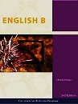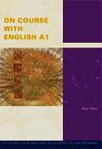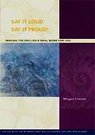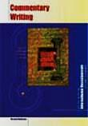
ENGLISH

QTY | TITLE | ISBN | RRP (HKD)
 | Commentary Writing: Writing an Unseen Passage for English A1 | 9781876659721 | $240
 | English B 3rd Edition | 9781921917127 | $390
 | On Course with English A1 | 9781876659691 | $225
 | Say it Loud, Say it Proud: English B oral | 1876659920EL | $900

Name:_________________________________________________ Dept: _______________________________
School Name: ________________________________________________________________________________
Order Number: _____________________________________________________________Date: ____/____/2013
Delivery Address: ____________________________________________________________________________
YORKE EDUCATIONAL CENTRE INTERNATIONAL BOOK BROKER
HONG KONG C/O MICHAEL ROTHLIN SUITE 3138, 31ST FLOOR 8 FINANCE STREET CENTRAL HONG KONG
Fax order to +61 9635 117 Please email for more information customerservice@yorkebooks.hk
AUSTRALIA 7 ARGYLE STREET PARRAMATTA 2150 NSW AUSTRALIA

